PFC - Workshop 03

Q1 (8 marks). Write a program that performs the following tasks:
- Input an integer number n (check input validation), then
- Display n in binary number format.
- Re-input n (not check input validation). Calculate sum of all digits of n.
- Find the number m, which is the reverse of n.

Sample input and output:
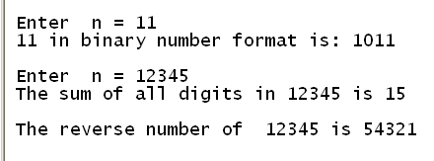

Additional questions (2 marks):
Q2. Write a program to accept 3 real numbers a, b and c, then
Solve the quadratic equation ax² + bx + c = 0.

Q3. Write a program to accept 2 integer numbers m and n, where m < n then
Display all palindrom numbers in the interval [m.n]. (A palindromic number or numeral palindrome is a number that remains the same when its digits are reversed, e.g. 16461)

